**IM 39003**

**Assignment 6: Particle Swarm Optimization**

**Due Date: Mar 4, 2021 Time: 5:30 PM**

*Instructions:*

*1. Submit this assignment via MS teams by 5:30 PM by turn- in/hand-in*

*2. You need to submit 2 files in zip file format: 1) Report 2) Code. Name your zip file as <your first name_your rollnumber>*

*3. In case of copying you will get a 0 grade for this assignment.*

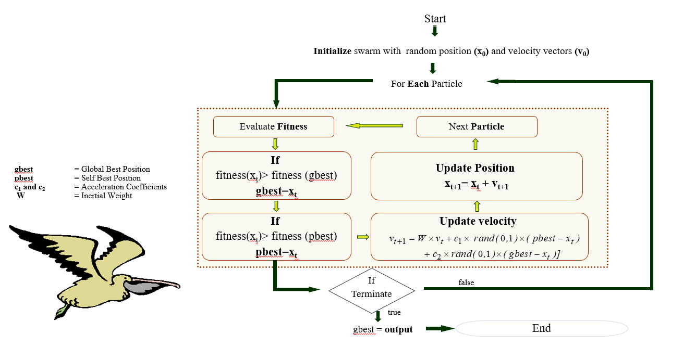

**Activity 1:** Based on the code provided prepare a report on following

* 1. Change # of population size: 10,20,…50
  2. Change inertia weight(W) : 0.1, ---,0.9
  3. Change the # of iteration :10:10:100
  4. Change the acceleration factor

C1 (for Pbest) 0:0.2:1

C2 (for Gbest) 0:0.2:1

* 1. Comment on what will happened when C1>C2 and C2>C1
  2. Comment on whether run has any effect

***Activity 2:***  Write a code for adding following two constraints to the objective function

$x_{1}+x_{2 }+x_{3 }≤5$

$x_{1}^{2}+2x_{2 }-x_{3 }≤0$

Use best set of parameters found in activity 1 to run the code.

---xxx---